1. RITM has been Submitted for approval

Subject: Requested Item RITM0010151 has been submitted for Approval

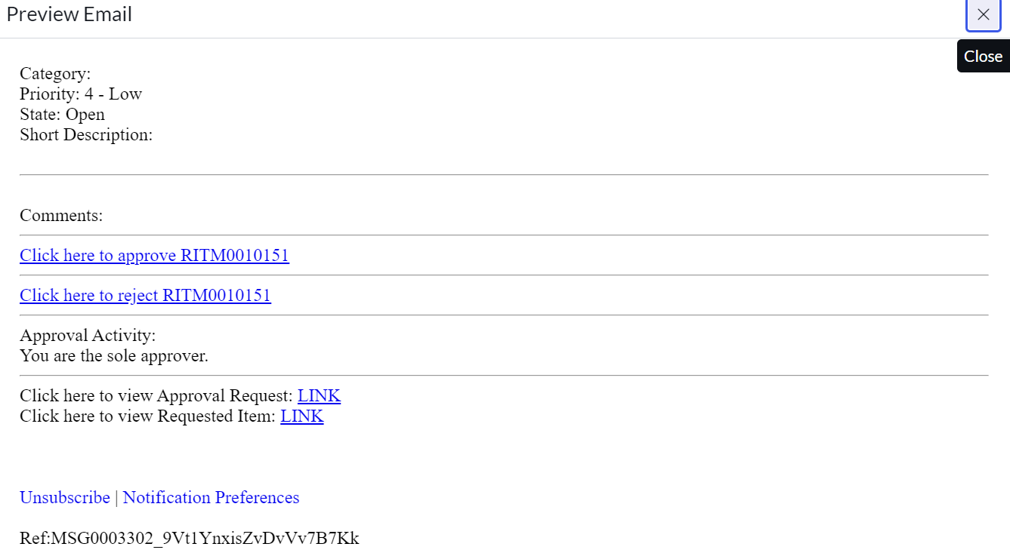

1. Request has been created

Subject :Request REQ0010153 was created

1. Request has been approved

Subject: Request REQ0010153 has been approved

1. Request has been Rejected

Subject: Request REQ0010147 has been Rejected

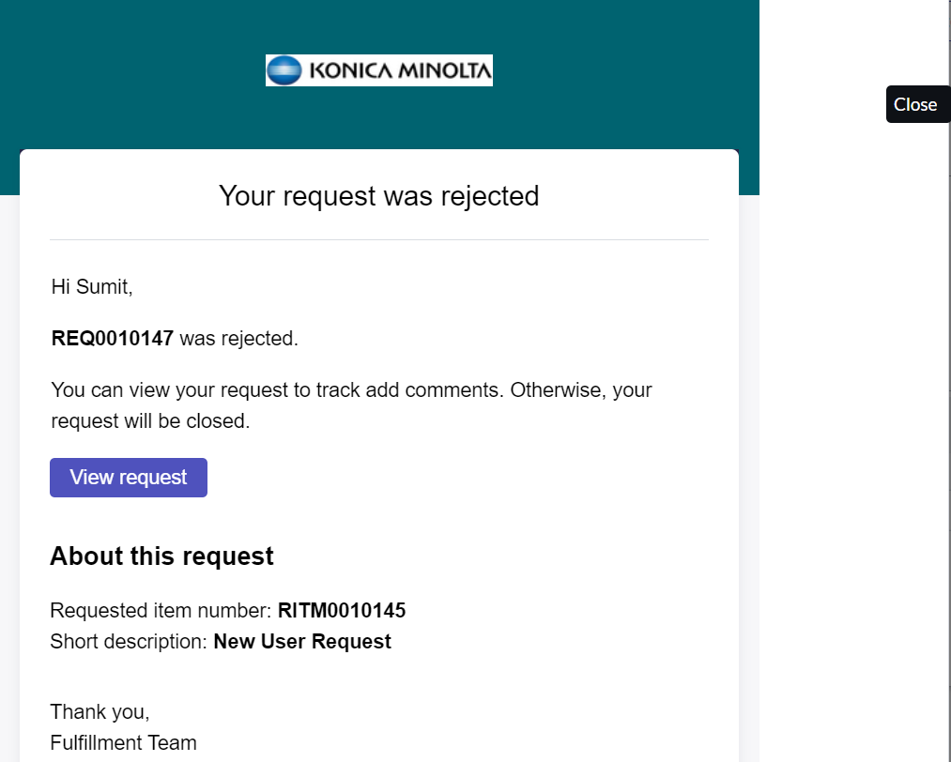

1. Approval has been rejected

Subject: Resubmit New User request

